**Task 1**

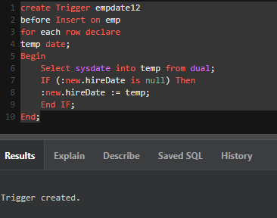

**Task 2**

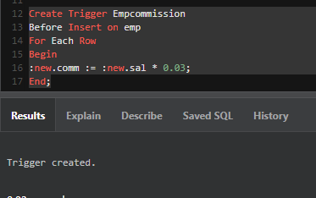

**Task 3**

An INSTEAD OF trigger is a trigger that allows you to skip an [INSERT](https://www.sqlservertutorial.net/sql-server-basics/sql-server-insert/), [DELETE](https://www.sqlservertutorial.net/sql-server-basics/sql-server-delete/), or [UPDATE](https://www.sqlservertutorial.net/sql-server-basics/sql-server-update/) statement to a table or a view and execute other statements defined in the trigger instead. The actual insert, delete, or update operation does not occur at all.

